Authorization for Release of Information for Employment Purpose

Background Screening Disclosure

I hereby authorize Proquest Consultancy Services Pvt Ltd, Hyderabad and its designated agents and representatives to conduct a comprehensive review of my background through a consumer report and/or an investigative consumer report to be generated for employment, promotion, reassignment or retention as an employee. I understand that the scope of the consumer report/investigative consumer report may include, but is not limited to, the following areas: names and dates of previous/current employment, work experience, worker’s compensation claims, criminal history records (from local, state, federal, international and other law enforcement agencies’ records), sexual offender’s lists, wants and warrants records, motor vehicle records, military records, educational verification, license verification, credit history, civil cases, OIG/GSA, OFAC/patriots act, any sanction lists, Prohibited Parties Check, , Professional Reference Check, ID Verification, Supervisor Check, Drug and FBI finger printing.

Authorization and Release

I, SATHYA NARAYANAN SUDHAKAR, authorize the complete release of these records or data pertaining to me which an individual, company, firm, corporation, or public agency may have. I authorize the full release of the information described above, without any reservation, throughout any duration of my employment at QENTELLI. I hereby release PROQUEST, and its agents, officials, representatives, or assigned agencies, including officers, employees, or related personnel both individually and collectively, from any and all liability for damages of whatever kind, which may at any time, result to me, my heirs, family or associates because of compliance with this authorization for release of information. I certify that all information provided below and on my resume is correct to the best of my knowledge. Any false statements provided in this form and my resume will be considered just cause for the termination of employment at any time. This authorization and consent shall be valid in original, fax, or copy form.

The following information is required by law enforcement agencies and other entities for identification purposes when checking records. It is confidential and will not be used for any other purpose.

**Sathya** **Narayanan** **Sudhakar**

________________________________________________________________________

Applicant’s Name (First) Middle Name Surname

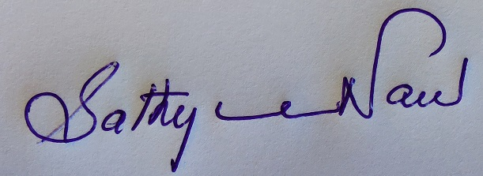

_______________________________________ **08/08/2023**

Signature Date

20/08/1989

Date of Birth (This will not affect hiring decision)

**TN3020080011167** **Tamil Nadu**

_____________________________ ____________

Driver License Number State

**H. No 4-129 and 130, Road no 13, Survey of India housing society, near Ayyappa society, Madhapur, Hyderabad**

________________________________________________________________________

Current Address

**(+91) 9952013313**

Phone